Permafrost researchs of Russia 2022
The main results
The past year was marked by the Sixth Geocryological Conference of Russia that was titled as "Monitoring in the permafrost zone". The Conference was held at Moscow State University from 14 to 17 June 2022. The 191 reports were heard at 13 sections. The main topics of the conference were:
- Gases and gas-hydrates in permafrost;
- Geocryological survey and mapping;
- Geocryological monitoring;
- Geophysical research in permafrost;
- Geocryological dynamics;
- Climate change and permafrost reaction;
- Engineering geocryology and engineering surveys in the permafrost zone;
- History, methodology and education in geocryology;
- Lithogenetic geocryology;
- Foundations and and engineering structures in the context of climate change;
- Physical chemistry, thermal physics and mechanics of frozen soils;
- Regional and historical geocryology;
- Ecological and biological problems of permafrost.

*****
Melnikov Permafrost Institute, Siberian Branch, Russian Academy of Science
(MPI SB RAS, Yakutsk) http://mpi.ysn.ru
Selected Research Results 2022
A new thermal control method and device for pavements and subgrades on permafrost
A new method for active thermal protection of engineering structures on permafrost has been theoretically demonstrated and a device has been developed utilizing the method (Heat Protection Element, Russian Federation Patent for Utility Model No. 212670 publ. 02.08.2022, Bull. No. 22). This device is innovative in that it can change its heat transfer resistance (increase at temperatures above 0°C and decrease at temperatures below 0°C) depending on ambient air temperature (Fig. 1). This allows effective cooling of the active layer in winter and reduction of thaw penetration in summer.
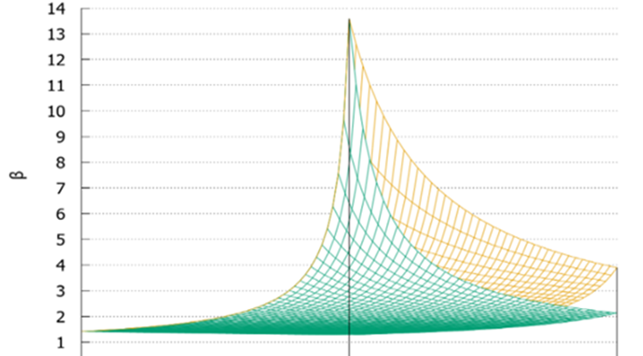
Fig. 1. Degree of increase (decrease), β, of heat transfer resistance of the heat protection element in winter.
Related publications:
1. Galkin A.F., Zheleznyak M.N., Zhirkov A.F. (2022). Selection of thermal insulation material for the structural layer of road clothing. Advances in Current Natural Sciences, 8: 108-113.
2. Galkin A.F. (2022). Equivalent thermal resistance of road pavements. Arktika i Antarktika, 3: 129-138.
3. Galkin A.F. (2022). Controlling the thermal regime of the road surface in the cryolithic zone. Transportation Research Procedia, 63: 1224-1228.
4. Galkin A.F., Zheleznyak M.N., Zhirkov A.F. (2022). Increasing thermal stability of the roads in cryolithic zone. Transportation Research Procedia, 63: 412-419.
5. Galkin A.F. (2022). Depth of the thermal effect of roads. Urbanistika, 4: 1-9.
Restoration of thermokarst-affected areas on ice-rich permafrost
A new method of thermal protection was proposed to rehabilitate lands deteriorated by thermokarst. The method involves a combination of insulating (restoring the vegetation) and high heat capacity (increasing the ground ice content) layers to provide for optimal heat exchange in the atmosphere–ground system on an annual basis. Results of numerical modeling and field experiments with several variants suggest that the method is effective and applicable to the areas underlain by ice-rich permafrost (Fig. 2).

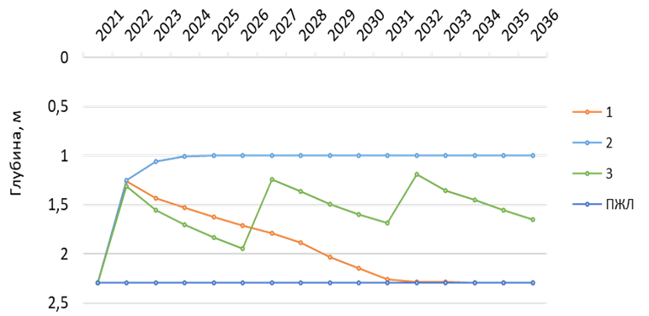
Fig. 2. Temporal variation in thaw depth at saturated moisture content in the active-layer for several snowcover scenarios:
1 – snow removal during the first year; 2 – snowcover is absent throughout the simulation period; 3 – snow compaction every 5 years; ПЖЛ – depth of ground ice.
Related Publications:
1. Zhirkov A.F., Sivtsev M.A. (2022). Assessing the feasibility of restoring the transient layer in Central Yakutia. In: Proc. Sixth Conf. Russian Geocryologists, Permafrost Monitoring, Moscow, 2022, pp. 444-450.
2. Sivtsev M.A., Zhirkov A.F. (2022). Numerical modeling of land rehabilitation in ice-rich permafrost terrain, Central Yakutia. In: Proc. XII Russian Conf. devoted to 65th Anniv. Institute of Diamond and Precious Metal Geology, Yakutsk, 2022, pp. 479-485.
3. Aleksandr Zhirkov, Maksim Sivtsev, Vasilii Lytkin, Anatolii Kirillin, Antoine Séjourné, Wen Zhi. Assessment of the possibility of restoration and protection of territories disturbed by thermokarst in Central Yakutia, eastern Siberia. Land. 2022 (in press).
Expeditions
In summer 2022, field teams led by N. Torgovkin and V. Tumskoy examined several yedoma exposures for the MPI basic research projects “Structure and Key Phases of Continental Permafrost during the Neopleistocene and Holocene” and “Cryolithogenesis of Quaternary Sediments in Northern Yakutia: Indigirka River Basin”. Cryostratigraphic studies were performed at the Tyalychyma natural exposure on the Vilyui River and the Mamontova Gora stratotype on the Aldan River, as well as in the Indigirka River basin (Fig.3). The teams included undergraduate students from the Moscow State University.
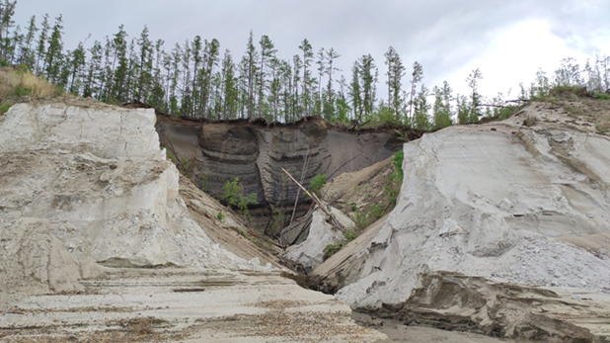  A | 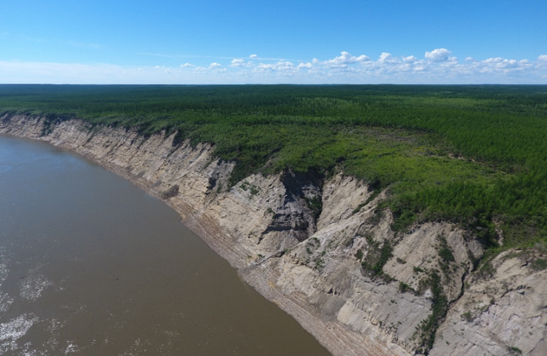  B
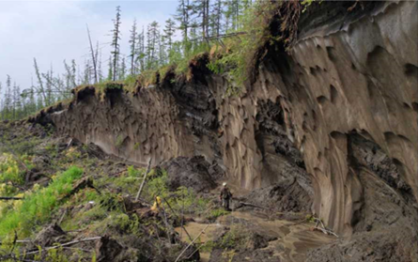  C | 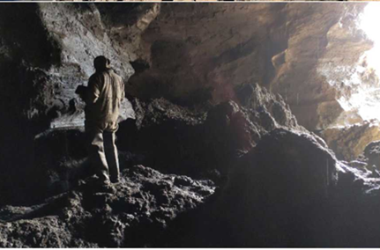  D
Fig. 3. Field study sites: A –Tyalychyma yedoma exposure, east bank of the Vilyui River (photo by N. Torgovkin); B – a 35-m terrace of the Mamontova Gora stratotype (drone photo by D. Sivtsev); C – yedoma exposed on the east bank of the Indigirka River, Abyi lowland; D – yedoma deposits in an abandoned adit near the Malakhchyn exposure.

A. Shepelev took part in a reconnaissance survey of the Lena River basin ecosystems conducted in the Aldan, Zhigansk and Bulun districts of Yakutia under the auspices of the strategic project "Global Earth Changes: Climate, Ecology, and Life Quality” based at Tomsk State University. The sub-project, “Estimating Permafrost Degradation in Arctic Coastal and Offshore Areas, Northern Asia”, seeks to estimate organic, inorganic and total carbon contents in soils and permafrost, as well as to analyze the local distribution of various forms of carbon in the Lena Delta deposits.
Publications
The Atlas of Giant Aufeis Fields in Northeastern Russia, by V.R. Alexeev, O.M. Makarieva, A.N. Shikhov, N.V. Nesterova, A.A. Ostashov and A.A. Zemlyanskova. Novosibirsk: SO RAN, 2021, 302 pp.
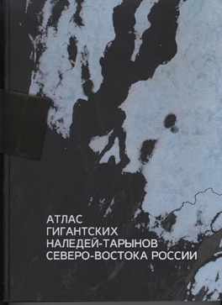
Satellite imagery series and in situ field observations were employed to obtain new information on the distribution, morphodynamics and long-term changes of giant aufeis fields, locally termed taryns, in the northeast of Eurasia. The information obtained is presented in The Atlas of Giant Aufeis Fields in Northeastern Russia, a first-of-its-kind mapping product that highlights this unique form of congelation glaciation. The Atlas consists of two parts, an illustrated text and maps. Part I narrates the history of research on giant aufeis fields, describes their origin, shape, size, structure and spatio-temporal changes, and discusses their relationships with permafrost, hydrogeologic, geomorphologic, hydroclimatic and geotectonic conditions. The role of aufeis in landform development and natural resources is explained. One of the chapters is dedicated to glacial and permafrost geohazards that affect critical infrastructure development. Part II contains over 100 maps of aufeis fields occurring in the basins of the major rivers in northeastern Russia, the Yana, Indigirka, Kolyma, Anadyr and Penzhina.

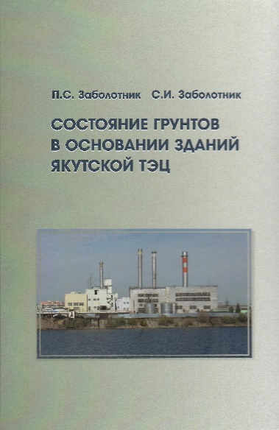
Ground Conditions at the Yakutsk Co-Generation Plant Site by P.S. Zabolotnik and S.I. Zabolotnik. Novosibirsk: SO RAN, 2022, 118 pp.
This book summarizes the long-term ground temperature observations at the Yakutsk Co-Generation Plant, a large heat and power generating facility on continuous permafrost. It presents a first case study assessing the long-term thermal effects of industrial buildings on underlying ground based on many years of monitoring observations. The data indicate that talik development beneath and around the plant buildings is mainly due to leakage of hot and aggressive water of the district heating system. Natural restoration of the ground thermal regime occurs very slowly, taking many years for the taliks to freeze back. The permafrost at the plant site shows no strong change in response to global climate warming. Ground temperatures at the foundation embedment depths beneath the buildings with low heat generation have only increased by 0.4-0.5°С over 80 years of the plant operation, while mean annual air temperature at Yakutsk has risen by almost 3°С.

*****
Earth Cryosphere Institute, Tyumen Scientific Centre, Siberian Branch, Russian Academy of Science (ECI Tyumen Scientific Centre SB RAS) http://www.ikz.ru/
The journal “Earth’s Cryosphere” (“Kriosfera Zemli”)
The results of the most fundamental and advanced investigations, important results on the programs of the Earth Cryosphere Institute (ECI SB RAS) and of the many others Institutes and organizations specializing on permafrost/cryosphere researches are presented in the journal “Earth’s Cryosphere” (“Kriosfera Zemli”). Journal is translated into English since 2014, all the articles are available online for free at the website of the journal: (http://earthcryosphere.ru/ , archive: http://earthcryosphere.ru/arch/). The abstracts of the most interesting papers are submitted for the consideration of readers.
2022 г.
1. Galanin A.A., Pavlova M.R., Vasil'eva A.N., Shaposhnikov G.I., Torgovkin N.V. Origin and isotopic composition of precipitation at extremely low temperatures in Yakutsk (Eastern Siberia). Earth’s Cryosphere 4, 2022, https://doi.org/10.15372/KZ20220402
Isotopic (¹⁸O, D) and chemical composition of atmospheric precipitation (1-2-cm snow layer on the surface of the snow cover and crystalline hoar), that fell in December 2020-January 2021 at anticyclonic weather, extremely low temperatures from -47 to -52 °C and dense ice fogs, has been studied at 6 sites along a 25-kilometer profile from Yakutsk. Samples from the surface of the snow cover are characterized by the lightest compositions (d¹⁸O = -41.04 ± 5.11 ‰, dD = -326.43 ± 34.16 ‰, d_{exc} = 1.91 ± 7.72 ‰) and are noticeably depleted with deuterium. From the outskirts to the center of Yakutsk, a significant weighting of the compositions has been established (by 10 ‰ in d18O, by 80 ‰ in dD), a decrease in d_{exc} (from +10 to -6 ‰), and a 4-fold increase in mineralization due to impurities of calcium carbonate. The isotopic compositions (d¹⁸O = = -30.89 ± 5.62 ‰, dD = -285.88 ± 12.82 ‰, d_{exc} = -28.79 ± 32.53 ‰) have been established for samples of crystalline rime, which are not typical for any atmospheric sediments, waters and ice of the region. They experience the greatest variations in d¹⁸O (from -24 ‰ in Yakutsk to -37 ‰ at a distance of 25 km from its center); the value of dD varies from -255.4 to -285.9‰, dexc increases from -80 to +11.5 ‰. The isotopic and chemical compositions of the investigated sediments indicate a significant proportion of technogenic water vapor entering the atmosphere during the combustion of hydrocarbon fuel. Based on the model of the Gaussian mixture and deuterium excess of the studied samples, it has been found that in crystalline hoar, the maximum share of technogenic moisture reaches 26-32 % near heat-generating stations, in the central part of the city - 13-18 %, and on the outskirts - 6.5-8.8 %; in the surface layer of the snow cover - 5-6 % in the central part of Yakutsk and decreases to the outskirts to 1 % or less.
2. Verkulich S.R. Climate, sea level and glaciation changes in the marginal zone of Antarctica during the last 50 000 years. Earth’s Cryosphere 2, 2022, https://doi.org/10.15372/KZ20220201
The article integrates the results of half a century studies of Late Pleistocene-Holocene changes in climate, sea level and glaciation in the marginal zone of Antarctica in order to identify the chronology, parameters, mechanisms of these changes under the influence of global, regional and local factors. During the interstadial (MIS 3), the natural conditions here resembled modern ones, and the sea level in some areas exceeded modern marks. The development of glaciation of the marginal zone from about 26 000 years BP went on when the temperature fell and the sea level dropped by 30-50 m. The growth of glaciation on the shelf outpaced the growth of ice on the outskirts of the continent, leading to a moisture deficit in the interior regions. During the LGM, there was a thin (less than 300 m) glaciation of coastal and mountainous land areas, and a thick (more than 1000 m) glaciation on the shelf. Deglaciation of the marginal zone began about 17 000 years BP due to rising sea level and global warming. Holocene climate changes in most areas had a general trend: warming in the early Holocene to about 8000 years BP and 4000-2000 years BP, cooling 2000-1500 years BP, but also had local differences. The relative sea level rose in the regions from the early Holocene to the period 8000-6000 years BP; then it fell with a decrease in speed and even with a possible rise of the level 2500-1300 years BP; local differences in the amplitudes and course of the level were determined by local tectonics and dynamics of deglaciation. Deglaciation rates were high from the early Holocene to about 7500 years BP due to warming and marine transgression; then the speed dropped. The advance of outlet and shelf glaciers 6500 and 4500 years BP was associated with a decrease in sea level and cooling. In the period 4000-1000 years BP, outlet and shelf glaciers could also respond to changes in sea level, and ice domes expanded according to the “warming-increasing humidity-increasing snow and ice accumulation” pattern. During the Little Ice Age, moraines were created in some areas, registering a slight increase in glaciers due to cooling.
3. Kopylov D.V., Sadurtdinov M.R., Yanin S.Yu. Georadar studies of ground ice in the complex of engineering and geological surveys. Earth’s Cryosphere 1, 2022, https://doi.org/10.15372/KZ20220106
The results of ground-penetrating radar studies in the complex of engineering and geological surveys at the design site of the cluster site of an oil and gas field in an area with a continuous spread of permafrost soils are considered. Drilling of geological wells with core sampling have revealed the presence of an ice ground lens with an ice content of up to 90 %. Comparison of the drilling results and the characteristic wave pattern on the ground-penetrating radar sections have allowed us to identify the area of abnormal changes in soil properties, which is interpreted as an ice-ground lens. High-amplitude diffractions of an electromagnetic wave are distinguished at the “ice-ground-peat” boundary, which, according to the authors, are due to the presence of wedge ice bodies. The lens of the ice ground has been contoured and its approximate volume has been calculated with the help of attribute analysis.
4. Chernov R.A., Romashova K.V. Current state of glacial lakes on Svalbard. Earth’s Cryosphere 1, 2022, https://doi.org/10.15372/KZ20220104
The current state and the quantitative estimates of glacial lakes on Svalbard are presented. These lakes were formed in depressions under modern recession of glaciation of the archipelago. Based on Norwegian aerial photography 2008-2012 and mosaics of Maxar Vivid 2013-2019 images of Svalbard area, 629 new glacial lakes have been identified. These lakes are located on deglaciated areas. A map of new lakes and their distribution by territory and altitudes are presented. Most of glacial lakes are located in western and southern parts of Svalbard, where large-scale glacier retreat has been noted. At the same time, new glacial lakes are formed mostly in the northern and eastern parts of the archipelago where most of the lakes have ice coasts. The total length of ice coasts of 306 lakes was (233.8 ± 0.6) km in 2008-2019, which is comparable to the length of the fronts of the outlet glaciers of Svalbard. The total area of glacial lakes is (173.1 ± 0.7) km², and their total water volume ranges from 2.1 to (2.3 ± 0.1) km³.
5. Iudina V.A., Chernomorets S.S., Vinogradova T.S., Krylenko I.N. Modeling of debris flow triggered by snow melting: case study of the Barsemdara River, Tajikistan. Earth’s Cryosphere 3, 2022, https://doi.org/10.15372/KZ20220306
The last catastrophic debris flow disaster took place in Tajikistan in the Barsemdara River valley in 2015. The aim of this study was to apply chain modeling to consider debris flow characteristics of 2015 year. This approach has also been applied to assess potential flood prone zones for future debris flows. To consider the characteristics of debris flow in the source, the transport-shift model, developed by Yu.B. Vinogradov was applied. Based on this model, debris flow hydrographs were obtained and used as input data for valley zoning based on the FLO-2D model. So, for scenario I, the debris flow discharge of the forward wave was used as the input hydrograph (maximum -1630 m³/s), the II scenario – the debris flow discharge at the source outlet (maximum 650 m³/s). The digital elevation model ALOS PALSAR (12.5 m) was used as the relief data. Since there are no rheological data, the modeling was carried out using several sets of parameters. The simulated debris flow discharges based on the most realistic option for I scenario varied from 1494 to 2860 m³/s for individual waves. Additionally, the authors carried out modeling using digital elevation model from an unmanned aerial vehicle obtained during the survey in 2019. The results showed that the considered approach makes it possible to estimate the boundaries of both actual and potential flood prone zones.
6. Slagoda E.A., Novoselov A.A., Koroleva E.S., Kuznetsova A.O., Butakov V.I., Tikhonravova Ya.V., Zazovskaya E.P. Traces of cryogenic processes in the Late Pleistocene sediments of the Pur-Taz interfluve (West Siberia). Earth’s Cryosphere 1, 2022, https://doi.org/10.15372/KZ20220103
Reconstruction of paleoenvironmental conditions, origin of sediments and permafrost evolution as well as identification of cryogenic and paleocryogenic formations based on sediment cores (small fragments of geological record) are among key scientific problems of cryolithology. We have analyzed grain-size distribution, geochemistry, and water content of sediments from the permafrost section in the North of Pur-Taz interfluve (West Siberia). Moreover, we have described the floristic composition of plant remnants, their age and the cryostructures found within these sediments. Optical and electron microscopy revealed the micromorphological features of thin sections and specimens of rocks. Based on the sediment core data from the borehole, we have established the alluvial, lacustrine and proluvial origin of sediments. Furthermore, we have reconstructed the conditions of sedimentation in this area and have established the Karginsky age of these sediments. This age corresponds to formation of 3rd lacustrine-alluvial plain in the lower course of Taz River. The conditions of early diagenetic transformations of sediments as well as epigenetic and syngenetic permafrost were reconstructed based on cryogenic and post-cryogenic formations, cryostructures, microstructure and authigenic minerals. We were also able to reconstruct the Late Pleistocene sequences of freeze-thaw cycles in the upper part of the permafrost section of the Pur-Taz interfluve.
7. Ivanov K.S., Melnikova A.A. Construction of buildings in the Arctic with the application of granulated foam-glass ceramics in their bases. Earth’s Cryosphere 6, 2022, https://doi.org/10.15372/KZ20220603
The construction of heated buildings in the Arctic is considered. To increase the bearing capacity of the foundations via their preservation in the frozen state, an environmentally friendly heat-insulating material obtained from the Arctic raw materials (opal-cristobalite and zeolite rocks) has been proposed. The aim of this work is to evaluate the efficiency of insulation layer made of granular foam-glass ceramic on the basis of numerical modeling of the thermal interaction between the heated building and the frozen base. We have investigated the influence of protective screens, construction parameters of a dome-shaped building, and the thickness of insulation layer on the thermal regime of a frozen base over 30 years in comparison with the option without the use of special engineering measures. Calculations indicate that the safe exploitation of a heated building without traditional seasonal cooling devices and a ventilated underground is only possible with the use of protective screens. The building can have the shape of not only a dome but also an elongated ellipsoid of unlimited length. In this case, for building width of 6–8 m, the thickness of insulation layer should be 1–1.4 m. The proposed technology is promising to reduce the cost of low-rise Arctic construction, rational use of mineral resources, and preservation of the permafrost and Arctic landscapes.
8. Kirillin A.R., Zhelezniak M.N., Zhizhin V.I. New data on thickness of permafrost at the Leno-Aldan watershed. Earth’s Cryosphere 3, 2022, https://doi.org/10.15372/KZ20220301
The data on the ground temperature up to the depth of 650 m in a well with a restored thermal regime have been obtained for the first time for the Lena-Aldan interfluve. The abnormal permafrost thickness for this territory (750-780 m) has been determined by geothermal measurements. The change of ground temperature with depth displays the nonstationary contemporary regime of permafrost with the negative geothermal gradient up to a depth of 300 m. The permafrost thickness has been estimated and the possible reasons of its difference in relatively nearby areas are considered.
9. Alekseev A.G. Tangential frost heaving forces of clay and sandy soils acting along the metal surface. Earth’s Cryosphere 3, 2022, https://doi.org/10.15372/KZ20220303
The results of experimental studies of the tangential frost heaving forces of clay and sandy soils in laboratory conditions on three installations with different single-plane shear rates at constant normal load are presented. The installations made it possible to perform conditionally instantaneous shift, long-term tests with the application of a stepwise shifting load and a shift at a constant speed. As a result of complex studies, the dependences of shear resistance or equivalent tangential forces of frost heaving of sand and loam on water content (from 10 to 28 %) and temperature (from 0 to -10 °C) on the metal surface have been established. An increase in soil water content and a decrease in soil temperature leads to an increase in the resistance to soil shear. The shear resistance of sand is up to 2 times higher than similar values for loam under identical shear conditions, temperature and water content. An increase in soil moisture leads to an increase in the contact area of soil particles through ice layers with a metal foundation and to an increase in the bonds between the particles as a result of an increase in the volume of ice. It is established that the resistance to conditionally instantaneous shear is up to 3 times higher than the values of extremely long-term shear resistance and shear at a constant speed under similar thermal humidity conditions.
10. Ananicheva M.D., Abramov A.A., Kononov Yu.M., Patrikeeva I.A., Pakin G.Yu. Features of glaciation in the northern Baikal area at the beginning of the 21st century. Earth’s Cryosphere 6, 2022, https://doi.org/10.15372/KZ20220604
Glaciation of the northern Baikal region is associated with mountain ranges surrounding Lake Baikal. The underlying rocks are in the frozen state. The existing glaciers are remnants of a larger Pleistocene glaciation, and their area is subjected to continuous shrinking. The analysis of tree cores allowed us to reconstruct the climatic background of the glaciation changes in the recent past. A dendroclimatic curve is divided into two parts: the first part lasted until about 1860–1865, when the summer air temperature was almost always below the mean summer temperature for the entire considered period (~16°С); the second part (until now) is characterized by higher (above-average) temperatures. During the field work, the current state of the regional glaciation was described for the areas of the Baikal, Barguzin, and Verkhneangarsk ranges. The areas of glaciation were determined from the Landsat 7 and Sentinel-2 satellite images for 2000 and 2021 and were controlled by orthophotoplans based on the UAV survey in August 2021. The maximum reduction of glaciated area over 21 years is generally typical for small forms of glaciation and reaches 10–30% for the main glaciers. Data on temperature regime of air and rock surface along an altitudinal profile in the Verkhneangarsk Range were obtained for the first time.
11. Shavlov A.V., Yakovenko A.A., Yakovenko E.S. Experimental studies and a new model of the Workman-Reynolds freezing potential of water. Earth’s Cryosphere 5, 2022, https://doi.org/10.15372/KZ20220501
New experimental data have been obtained on the Workman-Reynolds freezing potential of water and the electric current from an external source through the ice melting front. A new model of the phenomenon is proposed, which takes into account the capture of protons and hydroxide ions by interstices of the ice lattice acting as charge traps. The model provides a semi-quantitative explanation of the observed features of the phenomenon.

*****
Sergeev Institute of Environmental Geoscience RAS (IGE RAS, Moscow) http://geoenv.ru/index.php/ru/
2022
The Institute of Geoecology of the Russian Academy of Sciences continued regular geocryological observations in Northern Transbaikalia (Fig. 1). Geotemperature measurements have been made. The multidirectional response of permafrost to climate change in different landscapes has been confirmed.

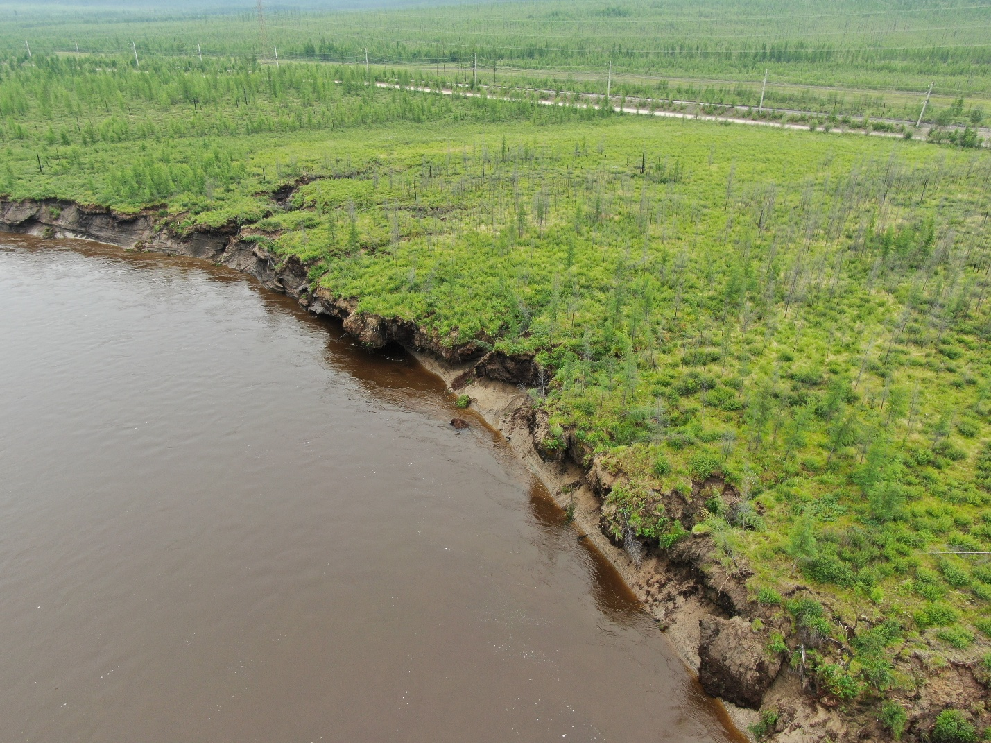
Fig. 1. Collapsing peat massif with polygonal ice-wedges on the First terrace of the Chara River, Northern Transbaikalia.
The training practice of master geocryologists of Moscow State University was supported in the North of the European part of Russia and in Salekhard (Fig. 2). The main content of the training course is training in permafrost survey methods with the preparation of a geocryological map based on a set of mutually agreed observations. Permafrost survey materials are used to assess geocryological hazards for infrastructure facilities (roads, railways, pipelines).

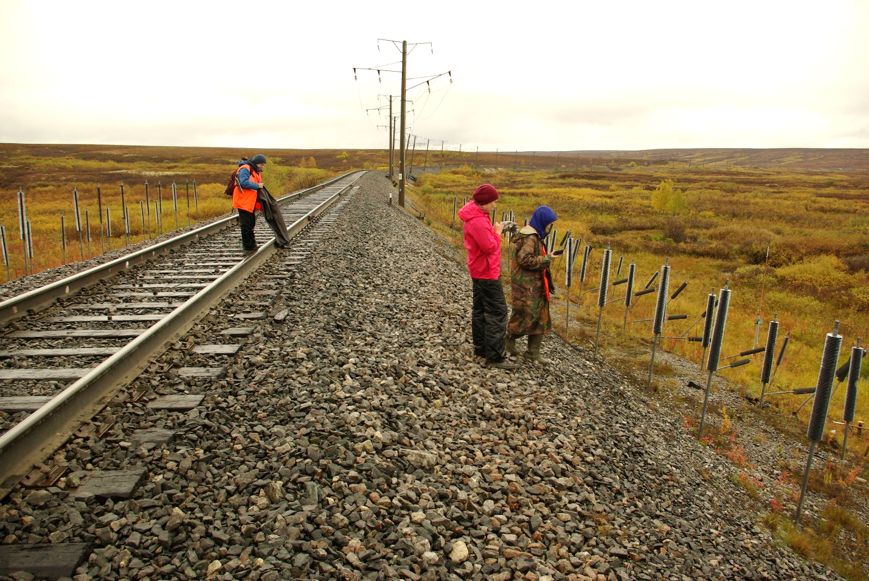
Fig. 2. Observations on the stability of infrastructure facilities in the Russian Arctic.

*****
Institute of Physicochemical and Biological Problems in Soil Science, RAS (Soil Cryology Laboratory)(Pushchino, Russia) http://www.issp.psn.ru/
2022
The results about presence and viability of thermophilic microorganisms in volcanogenic permafrost deposits were summarised and published in Astrobiology. In some samples the methane production was significant, even at low temperatures. New methanogenic Archaeon from West Spitsbergen permafrost was described and sequenced. Possible approaches to the classification of soils of the accumulative seashores of the Russian Northeast were published in Eurasian soil science. Approaches for the complex assessment of polychemical pollution of permafrost-affected soils and the upper layer of permafrost were published in Environmental monitoring and assessment.
1. Vishnivetskaya, T.A., Mironov, V.A., Abramov, A.A., Shcherbakova, V.A. and Rivkina, E.M. (2022) Biogeochemical Characteristics of Earth's Volcanic Permafrost: An Analog of Extraterrestrial Environments // Astrobiology, 22(7) https://doi.org/10.1089/ast.2021.0137
2. Trubitsyn, V., Rivkina, E. and Shcherbakova, V. 2022. Draft Genome Sequence of a Methanogenic Archaeon from West Spitsbergen Permafrost // Microbiology Resource Announcements, 11(2), pp.e00938-21. https://doi.org/10.1128/mra.00938-21
3. Gubin S.V., Lupachev A.V. Approaches to the Classification of Soils of the Accumulative Seashores of Russian Northeast (2022) // Eurasian Soil Science,55(1):20–26: https://doi.org/10.1134/S1064229322010057
4. Aleksei Lupachev, Petr Danilov, Evgeny Lodygin, Yana Tikhonravova, Vladislav Butakov, Anna Usacheva, Marta Ksenofontova (2022). Approaches for the complex assessment of polychemical pollution of permafrost-affected soils and the upper layer of permafrost // Environmental Monitoring and Assessment 194:594. https://doi.org/10.1007/s10661-022-10270-x

*****
Cryolithology and Glaciology Department, Geographical Faculty, Lomonosov Moscow State University

In 2022 researchers of Cryolithology and Glaciology Department, Geographical Faculty, Lomonosov Moscow State University continues study within 5-year project “The cryosphere evolution under climate change and anthropogenic impact”.
Manifestations of relict permafrost in the relief and Quaternary deposits of the steppe landscapes of the southeast of the East European Plain were established and the role of permafrost processes of the past in the modern landscape structure was determined. As a result of joint work with the Earth Cryosphere Institute (ECI SB RAS), regularities in the quantitative distribution of methane in frozen and thawing sediments of the western Arctic have been established. A comparative analysis of the tundra landscapes stability on the Gydan Peninsula and Eastern Chukotka was carried out.
Together with colleagues, the processing of field study data from Batagay RTS was carried out. The thaw slump internal structure and headwall shapes are determined by the varying permafrost properties of the sections, including ice content and wedge-ice presence, and the varying diurnal and seasonal insolation of different parts of the headwall reaching up to 55 m height.
- Ryabukha A.G., Polyakov D.G., Streletskaya I.D., Kovda I.V. Morphology and modern functioning of chalky polygons in Obshchy Syrt; southeastern East European Plain. Geomorfologiya i Paleogeografiya. 2022; (3):128-133. (In Russ.) https://doi.org/10.31857/S0435428122030130
- Kizyakov, A. I., Wetterich, S., Günther, F., Opel, T., Jongejans, L. L., Courtin, J., Meyer, H., Shepelev, A. G., Syromyatnikov, I. I., Fedorov, A. N., Zimin, M. V., Grosse, G. Landforms and degradation pattern of the batagay thaw slump, northeastern siberia. Geomorphology 420 (2022), 108501. https://doi.org/10.1016/j.geomorph.2022.108501
It was continued monitoring of the Dzhankuat and Kolka glaciers (Central Caucasus), glaciers of the Aktru basin (Altai), glaciers of the Inner Tien Shan (Karabatkak, Sary-Tor, Bordu), and the Polar Urals. Values of mass balance of the glaciers were included in the annual national report for the World Glacier Monitoring Service "Global Glacier Change Bulletin".
Long-term winter observations of snow cover and avalanches were continued at the educational and scientific bases of the Faculty of Geography in the Elbrus region (Central Caucasus) and in the Khibiny Mountains. Field studies on the Khibiny glaciers in the summer season have confirmed their stability and size retention in recent years, despite the increase in average annual air temperature. An expedition snow surveys were carried out in Kamchatka, on the Kharaelakh ridge (near Norilsk), on the Caucasus, on the Polar Urals. The calculated characteristics of some avalanches in the studied mountain and recreational complexes have been obtained.
In collaboration with colleagues, the previously compiled catalog of glacial lakes of the Tien Shan, Pamir and Gissar-Alay was expanded on the basis of remote sensing data. Maps of the possible distribution of permafrost in the regions of the Zeravshan and Gissar ranges of the Tien Shan have been constructed.
- Veh, G., Lützow, N., Kharlamova, V., Petrakov, D., Hugonnet, R., Korup, O. Trends, breaks, and biases in the frequency of reported glacier lake outburst floods. EARTHS FUTURE 10 (2022), e2021EF002426. https://doi.org/10.1029/2021EF002426

