**Permafrost researchs report of Russia 2023**

***Selected Research Results***

**The longer version of Permafrost researchs report of Russia 2023 (*Main results - 2023*):** <http://www.ikz.ru/about/sovet>

*****

**Earth Cryosphere Institute, Tyumen Scientific Centre, Siberian Branch, Russian Academy of Science** (**ECI Tyumen Scientific Centre SB RAS**) [**http://www.ikz.ru/**](http://www.ikz.ru/)

**On November 29-30 (2023)**, the Scientific Research Institute of the Russian Academy of Sciences hold a conference "Towards UNDERSTANDING THE INTEGRAL IMAGE OF THE EARTH'S CRYOSPHERE".

**The journal “Earth’s Cryosphere” (“Kriosfera Zemli”)**

**The results of the most fundamental and advanced investigations, important results on the programs of the Earth Cryosphere Institute (ECI SB RAS) and of the many others Institutes and organizations specializing on permafrost/cryosphere researches are presented in the journal “Earth’s Cryosphere” (“Kriosfera Zemli”). Journal is translated into English since 2014, all the articles are available online for free at the website of the journal:** ([http://earthcryosphere.ru/](http://earthcryosphere.ru) ; and archive: <http://earthcryosphere.ru/arch/>)**. The abstracts of the most interesting papers are submitted for the consideration of readers.**

**(№1/2023)**

**HYDROGEOLOGICAL CONDITIONS IN THE LENA RIVER FLOODPLAIN NEAR YAKUTSK**

**N.A. Pavlova,V.V. Ogonerov, M.V. Danzanova, L.S. Lebedeva**

*Melnikov Permafrost Institute SB RAS, Merzlotnaya St., 36, Yakutsk 677010, Russia, napavlova@mpi.ysn.ru*

This paper investigates the hydrogeology and groundwater regime in the Lena River floodplain near Yakutsk, based on a detailed analysis of published and unpublished information, including field data collected by the authors in 2013–2021. Drilling data from more than 70 boreholes were examined to characterize the permafrost and hydrogeological conditions in the area. Data from groundwater level monitoring in the reclaimed area of the floodplain were also utilized. Over 250 sample analyses were interpreted to characterize the surface and ground water chemistry. The results suggest that suprapermafrost water in the high floodplain is recharged both by river water infiltration and by underflow through the bed of the river hydraulically connected to the floodplain taliks. The water chemistry of the Lena River and the taliks was found to vary seasonally and spatially. The surface water and the ground water of the Quaternary aquifer on the east side of the Lena River have the lowest total dissolved solid (TDS) concentrations (0.1–0.3 mg/l) and magnesium-calcium chloride-bicarbonate type. Here, conditions favor their recharge by fresh supra- and intrapermafrost waters from the Bestyakh Terrace and taliks beneath minor streams. Near Yakutsk, TDS concentrations in the Lena River and in the Quaternary aquifer increase to 0.5–1.3 g/l due to chloride and sulphate ions which have high mobility and migrate with surface and suprapermafrost runoff from the low terrace where the city is located.

**(№3/2023)**

**MOULINS, FORMATION AND SIGNIFICANCE**

**B.R. Mavlyudov**

*Institute of geography RAS, 119017 Moscow, Staromonetnyj per. 29, Russia, bulatrm@bk.ru*

The reasons and conditions for the formation and change of moulins are considered on the base of author’s own data and on publishing data. Moulins can form above the water level in crevasses in the ice column and cannot form below the water level. The cylindrical shape of moulins is associated with the spraying of water jets at a certain depth from glacier surface. Questions related to different mechanisms of moulin formation, their depth, age, water level fluctuations are considered. A possible connection between moulins and the internal drainage system of glaciers is shown. Since there are glaciers in which water does not penetrate to the bed through moulins, the question of the connection between moulins and thrusts in the ice thickness is being considered.

**(№3/2023)**

**THE** **CHANGES IN EARTH IRRADIATION DURING THE HOLOCENE**

**V.M. Fedorov1, D.M. Frolov1, E.A. Agafonova2**

1 *Lomonosov Moscow State University, Faculty of Geology, Department of Geocryology, 1, Leninskie Gory, Moscow, 119991, Russia;*

2 *Shirshov Institute of Oceanology of Russian Academy of Science, 36, Nakhimovskiy prospect, Moscow, 117997, Russia,* [*fedorov.msu@mail.ru*](mailto:fedorov.msu@mail.ru)

The paper investigates the change in the Earth's insolation by latitudes and seasons in certain geochronological periods of the Holocene. A comparative analysis of irradiation in the boundary years of geochronological periods of the Holocene with modern insolation (2022) is carried out. The change in summer insolation in the hemispheres within the Holocene is analyzed separately. Quantitative estimates of changes in the intensity of irradiation for geochronological periods of the Holocene and a comparative assessment with respect to modern irradiation are obtained. The extrema of summer insolation in the Northern hemisphere were determined, with which the global paleogeographic events of the Holocene are synchronized: the transition from the cold Pleistocene epoch to the warm Holocene epoch and the Little Ice Age. It is shown that the change in the summer irradiation of the Northern hemisphere, determined by the characteristics of the Earth's orbital motion, is a factor in the noted global paleogeographic events, and the Northern hemisphere of the Earth is the arena of their occurrence and predominant development.

**(№4/2023)**

**long -term monitoring of active layer tHickness in typical tundras of western Yamal**

**Vasiliev А.А.1,2, Oblogov G.E.1,2, Shirokov R.S.1**

*1Institute of the Earth’s Cryosphere of Tyumen Scientific Center of Siberian Branch of Russian Academy of Sciences, 625000 Tyumen, Malygina st., 86, Russia;*

*2Tyumen State University, 625003 Tyumen, Volodarskogo st., 6, Russia, al.a.vasiliev@gmail.com*

The observations result of the interannual dynamics of the seasonal thawing depth in the dominant landscapes of a typical tundra on the territory of the Marre-Sale geocryological station (western coast of the Yamal Peninsula) are presented. It is shown that drained landscapes have the maximum response to changes in climatic conditions, while wet and water saturated landscapes have reduced increase rate of the active layer depth. The slow increase in the depth of seasonal thaw during the current climate warming is explained by the presence of ice-rich horizon in the upper part of permafrost, subsidence of the day surface, and an increase in the height of the moss cover. The uneven growth of vegetation, primarily mosses, forms a large contrast in the spatial distribution of the active layer depth. For a regional assessment of the thaw depth, it is proposed to use a weighted average value that takes into account the share of each landscape in the overall landscape structure of the region.

(№5/2023)

FROZEN AND COOLED SOILS OF THE BAYADARA BAY CRYOLITHOZONE

**S.I. Rokos1, D.A. Kostin2, A.V. Tulapin1, S.N. Kulikov1, А.G. Dlugach1**

*1“Arctic Marine Engineering-Geological Expeditions” (AMIGE), Russia,*

*19 Karl Marks St., Murmansk, 183025*

*2«Murmansk State Technical University»,*

*13 Sportivnaya St., Murmansk, 183010, RokosSI@rusgeology.ru*

The purpose of the scientific work is to establish the genesis and formation conditions of various types of soils that are part of the permafrost zone of Baydara Bay. Based on temperatures of the core samples obtained during geotechnical drilling, as well as thermal cone penetration tests performed along the track of the underwater gas-pipeline transition site located in the cryolithozone of the Baydara Bay, some cooled and frozen deposits have been discovered. These deposits are proposed to be formed within epigenetic frozen stage occurred during the Sartan regression. The samples corresponded to this group are mainly represented by softly-frozen clayey soils and icy-clays, as well as ice ground. These deposits are mainly originated at significant depths and formed a local frozen massive in the eastern part of the explored track. Considering seasonally frozen deposits, which are predominantly composed of sands, two types of the formations can be identified. The first type is thought to be occurred at shallow-depth water sites near the seabed during the cold seasons (where the fast ice grows to seafloor). The second type is proposed to be formed at the relatively deeper part of the water basin during the cold seasons, when temperature of the near-bottom waters decreases below to the frozen point. The cooled deposits can also be subdivided into two groups: permanently-cooled and seasonally-cooled varieties. The permanently-cooled deposits are typically located below the 00C isotherm in the warmest season of the year. The seasonally-cooled deposits are located above the   
00C isotherm and usually have positive temperatures, however, in winters, such varieties due to negative temperatures of the cold near-bottom waters, can also be temporary modified into cooled state.

**(№5/2023)**

**GEOELECTRIC STRUCTURE OF THE SUBAQUATIC CRYOLITHOZONE IN UOMULLAKH-KYUEL LAGOON (LAPTEV SEA)**

**V.V. Olenchenko1*, A.N. Faguet1, P. Overduin2, M. Angelopoulos2**

1 *Trofimuk Institute of Petroleum Geology and Geophysics​ of Siberian Branch Russian Academy of Sciences (IPGG SB RAS), Koptug ave. 3, Novosibirsk, Russia, 630090;*

2 *Alfred Wegener Institute Helmholtz Centre for Polar and Marine Research, Potsdam, Germany,* *Gebäude A45 14473. olenchenkovv@ipgg.sbras.ru*

We performed geophysical studies to determine the structure of the frozen layer around and below the Uomullyakh-Kyuel Lagoon, the lagoon itself being a reference landform sculpted by thermokarst and thermal abrasion of the sea shoreline. The main purpose of the study was to determine talik depth under lagoon or the position of the subaquatic permafrost boundary.

We performed electromagnetic and electrical studies with transient electromagnetic sounding and electrical resistivity tomography from lagoon ice during winter period and from water surface in summer. We matched borehole section data with temperature data from this same borehole and also with surface geophysical data. This comparison showed patterns of modern and relict taliks in the form of low electrical resistivity layers. We demonstrate that modern talik has developed to the depth of 30 m. At the same time, the relict talik is located between depths of 80-100 m, which correlates with data acquired by other researchers. We suggest that relict talik has a hydrological connection to the strata located under the seafloor therefore it is seen clearly on geoelectric cross section. The lake that formed the relict talik had a size of at least 1450 by 900 m.

Electrical resistivity tomography data acquired from the lagoon surface shows fragments of boundaries between frozen and unfrozen permafrost. Numerical modeling shows that electrical resistivity tomography quantitatively underestimates resistivity of the frozen permafrost by 5 to 10 times. In the subaerial-subaquatic transition zone, we track a gradual descent of the permafrost upper boundary and map a permafrost overhang, which sometimes appears beneath shallow water bodies. We suggest that gradual decrease of electrical resistivity in the direction from the seashore to the sea basin corresponds to the amount of salt transported into sediments and increase in their temperature.

**(№6/2023)**

**SALT TRANSFER IN FROZEN METHANE HYDRATE-CONTAINING SEDIMENTS DURING THEIR INTERACTION WITH SALT SOLUTIONS**

**Chuvilin E.M.1, Ekimova V.V.1, Davletshina D.A. 1, Bukhanov B.A. 1, Krivokhat E.O. 1**

1 *Center for Petroleum Science and Engineering, Skolkovo Institute of Science and Technology, Bolshoy Boulevard 30, Bld. 1, Moscow, 121205, Russia. e.chuvilin@skoltech.ru*

This study covered experimental modeling of the interaction of frozen hydrate saturated sandy sediments with salt solutions at negative temperatures. It is shown that the effect of salt ions in frozen hydrate-containing sediments is more active than in frozen hydrate-free samples. It was revealed that gas pressure is one of the main factors which control salt migration intensity in frozen hydrate containing sand, unlike in frozen non-hydrate ones. Gas pressure increasing and temperature rising cause decreasing of salt transfer in frozen hydrate-containing sands, while the pore hydrate preservation increases. On the base of experimental data, the salt transfer parameters of frozen hydrate-containing sandy sediments (salt flux density, diffusion coefficient) were obtained for the first time and depends on gas pressure and ambient temperature.

**(№6/2023)**

**NEW PSYCHROACTIVE BACTERIA OF THE YAMAL PENINSULA CRYOPEGS**

**Y. Ryzhmanova1, V. Trubitsyn1, E. Rivkina1, N. Suzina1, A. Plotnikov2, V. Kataev2, M. Molchanov3, N. Molochkov3, V. Shcherbakova1**

1*Federal Research Center “Pushchino Scientific Center for Biological Research of the Russian Academy of Sciences”, prospect Nauki 3, Pushchino, Moscow region, 142290, Russia;*

*2Institute for Cellular and Intracellular Symbiosis of the Ural Branch of the Russian Academy of Sciences,* Pionerskaya str.11, Orenburg, 460000, Russia;

*3Institute of theoretical and experimental biophysics of the Russian Academy of Sciences, Institutskaja str. 3, Pushchino, Moscow region, 142290,* Russia.[ryzhmanova@gmail.com](mailto:ryzhmanova@rambler.ru)

The new knowledge about the species diversity and metabolic potential of insufficiently explored microbial communities of the Yamal Peninsula cryopegs was provided. Calculation of the total number of microorganisms inhabiting cryopegs showed a high density within ~106-108 cells/ml. At the same time, sulfate-reducing bacteria were found only in two out of three cryopegs in numbers not exceeding 103 cells/ml. Representatives of the bacterial genera *Acetobacterium* (strains K1/0, K1/6 =VKM B-3638, K1/7, K1/8), *Labilibaculum* (K2ST, =VKM B-3650T) and *Trichococcus* (K1TrT, =VKM B-3651Т) were isolated from cryopegs for the first time. All isolates were psychroactive and able to grow at 6°C.

**(№6/2023)**

**INTERPRETATION SIGNS OF GROUNDWATER ICINGS ON SENTINEL-1 RADAR IMAGES ON EXAMPLES OF THE VERKHNYAYA NERUNGRA AND SAMOKIT AUFEIS OF SOUTHERN YAKUTIA**

**L.A. Gagarin, N.E. Baishev, A.E. Melnikov**

*Melnikov Permafrost Institute SB RAS, 36, Merzlotnaya str., Yakutsk, 677010, Russia. gagarinla@gmail.com*

Icings (aufeis) are an important component of the cryosphere and hydrosphere. It relates as a feature of ground water residence within permafrost region and potentially vulnerable to climate change, because is strongly controlled by weather conditions in winter. The goal of the study to estimate synthetic aperture radar (SAR) capability for icing development and icing landscape studies. Key sites are the Upper Neryungri river and the Samokit river valleys were chosen. Sentinel-1 SAR imageries were used. Verification of the interpreted data using Sentinel-2 images and field work landscape describing were done. Firstly, SAR image was processed and visualized in cross-polarization mod. The set of typical backscatter signal from the icing extent were extracted, and its representative points were chosen. Secondly, using Sentinel-2 picture a type of the icing landscape surface (ice, open water, snow cover, rock surface etc.) preliminary was established. Finally, icing landscape section and a feature of daylight surface were studied during field work within the earlier chosen points. The four ranges of a backscatter for VV and VH polarization reflected typical icing landscape sections were found. Further, due to high sensitivity of SAR beam to water content of an attacked object a resulted picture of backscatter intensity varies depending on a season. Finally, the areal extent of icing contours in spring at the Samokit and Verkhnyaya Nerungra River valleys were calculated based of SAR images and a NDSI, their variance was estimated.

**(№6/2023)**

**PERMAFROST-LANDSCAPE CONDITIONS** **IN THE ANABAR RIVER BASIN AT THE JOINT OF TUNDRA AND TUNDRA FOREST** **UNDER CONDITIONS OF MODERN CLIMATE WARMING**

**S. V. Kalinicheva, N.N. Nikiforova, I. E. Misaylov, N.A. Plotnikov, A.N. Fedorov**

*Melnikov Permafrost Institute SB RAS, Merzlotnaya str. 36, Yakutsk, 677010, Russia;* [*ikoveta@rambler.ru*](mailto:ikoveta@rambler.com)

The results of studies carried out on the border of the tundra and the tundra forest in the Anabar region of the Republic of Sakha (Yakutia) in order to study the dynamics of permafrost landscapes and identify the influence of vegetation on the temperature regime and thawing of ground are presented. It has been established that the Anabar tundra is overgrown with forest, the growth of which coincides in time with the second period of prolonged warming in the Arctic (1979-2011). The displacement of the tundra by forest also implies a change in the permafrost conditions of the underlying ground. Thus, according to the results of the study, it was found that the depth of the seasonally thawed layer has the greatest depth in the tundra area, with an increase in forest cover, the seasonally thawed layer decreases. The ground temperature, on the contrary, has low values ​​in the tundra, while the temperature of frozen ground is higher in pre-tundra forests. This paper presents the results of the first stage of the study. Further monitoring studies are planned in the area under consideration.

*****

**Melnikov Permafrost Institute, Siberian Branch, Russian Academy of Science (MPI SB RAS, Yakutsk)** [**http://mpi.ysn.ru**](http://mpi.ysn.ru)

**2023:**

Major patterns in coastal processes were determined for the Arctic zone of eastern Siberia. For all coastline segments identified, lithology, erosion rate, ice content, sediment and organic carbon fluxes into the Arctic basin from coastal erosion were defined. Erosion rates were estimated to vary between 0 and 25 m/yr depending on ground ice volumes in the coastal permafrost (Fig. 1). An East-Siberian coast database was developed and registered in 2023.

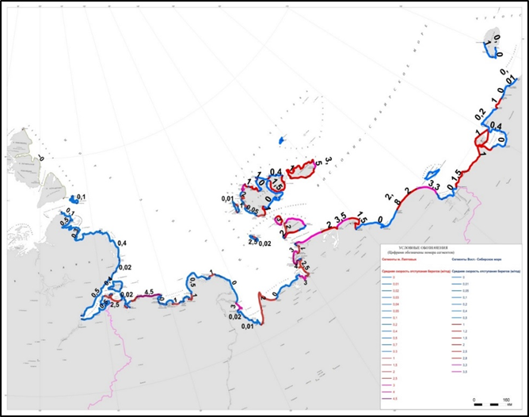

Fig. 1. Map of coastal retreat rates (m/yr) in eastern Siberia.

Related publication: *Kizyakov, A.I.; Ermolov, A.A.; Baranskaya, A.V.; Grigoriev, M.N. (2023): Morphodynamic types of the Laptev Sea Coast: A Review. Land 2023, 12, 1141. https://doi.org/10.3390/land12061141.*

A map of ice content in the upper 5–10 meters of permafrost was compiled for Arctic Yakutia. The map summarizes data acquired by MPI over several decades and is based on improved permafrost-landscape mapping methods, remote sensing of surface indicators, and GIS technologies (Fig. 2).

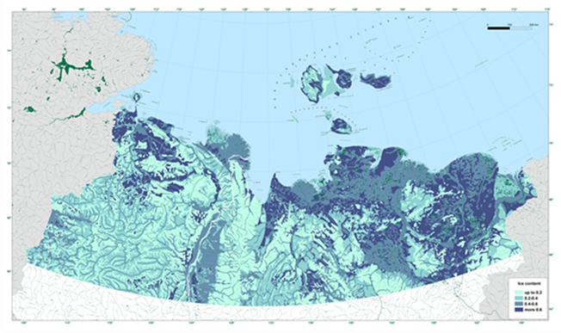

Fig. 2. Ground ice content map of Arctic Yakutia

Related publication: *Fedorov, A.N., Konstantinov, P.Y., Vasiliev, N.F., Basharin, N.I., Shepelev, A.G., Andreeva, V.A., Semenov, V.P., Torgovkin, Y.I., Desyatkin, A.R., Zheleznyak, M.N., and Semiletov, I.P. Ice Volumes in Permafrost Landscapes of Arctic Yakutia. Land 2022, 11 (12), 2329. https://doi.org/10.3390/land11122329.*

As part of the Russian Federation's Arctic Council Chairmanship Program (2021-2023), the International Conference on Climate Change and Permafrost Degradation was held in Yakutsk on March 22–24, 2023 hosted by the North-Eastern Federal University and the Melnikov Permafrost Institute. The workshop, titled "Coupled Natural and Technical Systems in Permafrost Regions under Changing Climate", became an important event of the conference. The workshop organized by MPI engaged 136 researchers from Russia, USA, China, and Kazakhstan (Fig. 3). Its program consisting of 94 talks featured a wide range of topics related to permafrost research and engineering for industry, mining, and transportation. Among the focal topics were challenges and solutions for urban development in northern regions, with many case studies from Yakutsk and Norilsk. Discussions centered around the development of an interdepartmental permafrost monitoring system in Russia founded on baseline and geotechnical observational networks, the establishment of federal and regional permafrost data collection, management and prediction centers, and the development and implementation of climate change adaptation strategies for the economy.

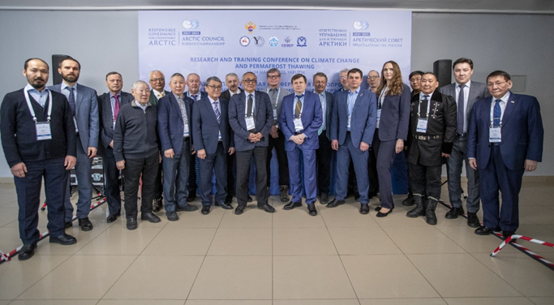

Fig. 3. Workshop session participants (Photo: <https://arctic-council-russia.ru>)

The Forum for Young Permafrost Scientists, seventh in a series organized by MPI, was held in Yakutsk from June 27 to July 07, 2023. The Forum 2023 which marked the 150 birthday of Mikhail Sumgin and the 100th birthday of Kirill Voitkovsky gathered over 60 participants representing Yakutsk, Mirny, St. Petersburg, Moscow, Tyumen, Salekhard, Tomsk, Irkutsk, as well as China, Kazakhstan and Belarus (Fig. 4). The Forum began with a four-day conference (June 27–30) covering six topics: regional and historical geocryology; hydrogeology and geochemistry; geothermics and thermal physics; engineering; climate change effects, and mapping and GIS. The Forum continued with a field trip (July 1–7) to observe periglacial processes in central Yakutia. Camping near Churapcha, the participants learned and trained field methods in application to permafrost, including groundwater survey, hydrological survey, geophysical methods, drilling, and thermal measurements (Fig. 5).

|  |  |
| --- | --- |
|  |  |
| Fig. 4. Conference participants. | Fig. 5. Lecture at a field camp. |

*****

**Sergeev Institute of Environmental Geoscience RAS (IGE RAS, Moscow)** [**http://geoenv.ru/index.php/ru/**](http://geoenv.ru/index.php/ru/)

The implementation of the state comprehensive study “Forecast, modeling and monitoring of endogenous and exogenous geological processes to reduce the level of their negative consequences” continues in Institute of Environmental Geoscience, Russian Academy of Science (IEG RAS). A block of research is being developed “Development of scientific and methodological foundations for assessing the state and forecasting the development of natural and technical systems of the Russian permafrost zone, taking into account the structural features and properties of frozen rocks in conditions of climate change and increasing technogenic load.”

In 2023, the work phase is devoted to the development of methods for studying the activity of cryogenic processes, identifying the causes of deformation of elements of transport infrastructure, as well as developing proposals to mitigate the negative consequences of changes in geocryological conditions. The work was carried out using data from a railway survey in Northern Transbaikalia and a highway survey in Central Transbaikalia. As a result, the scientific and methodological foundations for the associated assessment of the temporal and spatial features of the development of exogenous geological processes and deformations have been formed. The features of the structure and properties of permafrost under conditions of climate change and variable anthropogenic load are taken into account. It was revealed that the number and frequency of manifestations of cryogenic processes on different sections of the route in different years are different. This requires special engineering-geocryological zoning of the road strip to justify the sections and composition of monitoring and forecast. Criteria for ranking disturbed sections of track according to their degree of danger are proposed, as well as recommendations for the type of engineering protection.

IEG RAS also continued regular geocryological observations in Northern Transbaikalia. Geotemperature measurements were carried out in various landscape conditions, including in coarse clastic formations (kurums), characterized by a large negative temperature shift in the seasonally thawed layer (Fig. 1).



Fig. 1. Dynamics of mean annual temperatures in the coarse debris massif (kurum) at different depths (Udokan Ridge, Northern Transbaikalia, 1155 m a.s.l.).

The sixth European Conference on Permafrost Science (EUCOP 2023) took place in Spain from 18 to 22 June 2023. It featured 480 presentations and posters by permafrost scientists from all over the world. The conference organizers provided special organizational and information support to scientists from Russia, confirming the importance of Russian science for global development (Fig. 2).

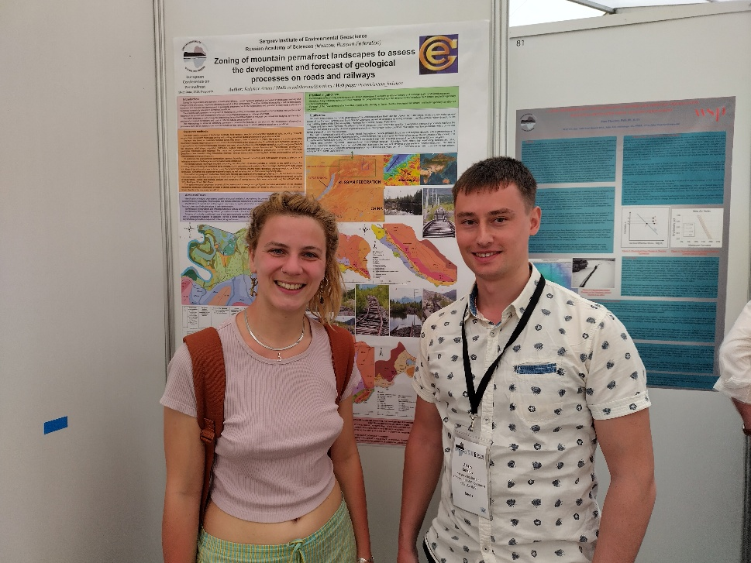

Fig. 2. A graduate student Artyom Kulakov from IEG RAS presents a poster at the EUCOP-2023.

Regional conferences dedicated to permafrost and problems associated with its condition and dynamics were held in Russia. In particular, from December 13 to 17, 2023, a satellite event of the Congress of Young Scientists in the Yamalo-Nenets Autonomous Okrug - “Permafrost, climate and design solutions: technologies for adaptation to ongoing changes” was held in Salekhard. This conference secured the region's status as Russia's leading expert platform for studying changes in permafrost and climate for the development of adaptation measures. Such satellite events are platforms for involving the Russian scientific community in solving problems of Russian regions, forming a system of setting tasks for the research and development sector in the regions through organizing discussions on the research agenda. The event was attended by representatives of regional authorities, industry and scientists from different regions of Russia, who proposed their solutions to the problems identified by the region. More than 50 reports were presented at the conference and five round tables were held.

In addition to regional conferences, industry conferences were also held. Thus, the First Industry Conference “Oil and Gas Infrastructure on Permafrost Grounds” (MMG-23) was held from November 22 to 24, 2023. The conference was organized by Gazpromneft PJSC and Peter the Great St. Petersburg Polytechnic University (SPbPU). The conference featured more than 70 reports in seven sections: Construction of wells permafrost, Design and construction of roads on frozen grounds, Foundations in permafrost and thermal stabilization technologies, Ecology and permafrost, New approaches in the field of education and training of personnel reserves, Geotechnical monitoring of oil and gas infrastructure, Reliability of pipelines in permafrost.

**References**

1. Napolov O.B., Kulakov A.P. Development of a scheme for the comprehensive restoration of disturbed and contaminated lands at the municipal level. In book: Use and protection of natural resources in Russia. 2023. №3 (175). p. 48-51. ISSN 2222-5633 (in Russian).
2. Kulakov A.P., Napolov O.B. Functional zoning of the Rostov region for assessing the tourist and recreational resources of the territory. In book: Use and protection of natural resources in Russia. 2023. №3 (175). p. 38-41. ISSN 2222-5633 (in Russian).
3. Brushkov A.V., Alekseev A.G., Badina S.V., Drozdov D.S., Dubrovin V.A., Zhdaneev O.V., Zheleznyak M.N., Melnikov V.P., Okunev S.N., Osokin A.B., Ostarkov N.A., Sadurtinov M.R., Sergeev D.O., Fedorov R.Yu. and Frolov K.N. (2023) Experience in operating structures and the need to control the thermal regime of soils in the permafrost zone // Journal of Mining Institute, 263, p. 742-756 (in Russian): https://pmi.spmi.ru/pmi/article/view/16277
4. Gorbunova A.A., Zaripova G.Z., Isaev V.S., Mansky V.N., Sobin R.V., Sergeev D.O., Bezdelova A.P. Temporal and spatial patterns of manifestations of cryogenic processes during the operation of railways in the southern part of the Bolshezemelskaya tundra under conditions of a changing climate // Geoecology. Engineering Geology. Hydrogeology. Geocryology, 2023, № 3, p. 15–25 (in Russian). DOI: 10.31857/S0869780923020054, EDN: TWJZJD
5. Makarycheva E.M., Merzlyakov V.P., Mironov O.K. Methodology for zoning the territory of extended linear objects according to the conditions of thermokarst formation // Earth’s Cryosphere, 2023, v. XXVII, №1, p. 58 – 66 (in Russian). DOI: 10.15372/KZ20230106
6. Kulakov A.P., Sergeev D.O. Development of exogenous geological processes and phenomena on the Udokan – Naminga highway (Northern Transbaikalia) // Geoecology. Engineering Geology. Hydrogeology. Geocryology. № 4. 2023. p. 53–62 (in Russian). DOI: 10.31857/S0869780923040057
7. Napolov O.B., Kulakov A.P. Criteria for typing various environmental situations at the territorial level // Astrakhan Bulletin of Environmental Education. №3 (75). 2023. p. 21–26 (in Russian). DOI: 10.36698/2304-5957-2023-3-21-26
8. Khimenkov A.N., Dernova E.O., Stanilovskaya Yu.V. Approaches to studying the influence of the gas component on the mechanical properties of frozen soils // Geoecology. Engineering Geology. Hydrogeology. Geocryology. 2023. № 1. p. 78–88 (in Russian). DOI: 10.31857/S0869780923010058
9. Khimenkov A.N., Koshurnikov A.V., Dernova E.O. Gas-saturated frozen rocks as an object of study of geocryology // Arctic and Antarctic. 2023. № 1, p. 26-64 (in Russian). EDN: PLNGUD URL:https://nbpublish.com/library_read_article.php?id=40378. DOI: 10.7256/2453-8922.2023.1.40378
10. Khimenkov A.N., Sergeev D.O., Kulakov A.P., Romanov A.V. — Features of the organization of engineering and geocryological monitoring of highways operated in areas where permafrost occurs // Arctic and Antarctic. 2023, № 4 (in Russian). EDN: ICMZSC URL: https://nbpublish.com/library_read_article.php?id=68814. DOI: 10.7256/2453-8922.2023.4.68814
11. Manual on Vorkuta geocryological scientific and educational practice / V. S. Isaev, P. I. Kotov, V. Z. Hilimonyuk, etc. General editor. P.I. Kotova, G.I. Gordeeva. M., Izhevsk: Institute of Computer Research, 2023, 228 p., ISBN 978-5-4344-0999-5 (in Russian and English).
12. Sergeev D. and Utkina I. Results of Permafrost Monitoring in the Mountains of Northern Transbaikalia BOOK OF ABSTRACTS - 6th European Conference on Permafrost (EUCOP 2023), Puigcerdà (Catalonia, Spain), 18-22 June 2023. Editors José M. Fernández-Fernández (Universidad Complutense de Madrid), Josep Bonsoms (Universitat de Barcelona), Julia García-Oteyza (Universitat de Barcelona), Marc Oliva (Universitat de Barcelona), p. 527. DOI: 10.52381/EUCOP6.abstracts.1
13. Kulakov A.P. Zoning of mountain permafrost landscapes to assess the development and forecast of geological processes on roads and railways BOOK OF ABSTRACTS - 6th European Conference on Permafrost (EUCOP 2023), Puigcerdà (Catalo-nia, Spain), 18-22 June 2023. Editors José M. Fer-nández-Fernández (Univer-sidad Complutense de Ma-drid), Josep Bonsoms (Universitat de Barcelona), Julia García-Oteyza (Uni-versitat de Barcelona), Marc Oliva (Universitat de Barcelona), p. 490. DOI: 10.52381/EUCOP6.abstracts.1
14. Kulakov A.P. Large-scale mapping of the soil cover of the mountain permafrost zone. In: Permafrost soils in the Anthropocene: collection of abstracts of the All-Russian Scientific and Practical Conference (Salekhard - Labytnangi, Yamal-Nenets Autonomous Okrug, Russia, August 20-26, 2023) / rep. ed.: A.V. Lupachev, E.M. Laptev. – Syktyvkar: IB Federal Research Center Komi Scientific Center Ural Branch RAS, 2023. – p. 147-148 (in Russian). ISBN: 978-5-6050144-1-6. DOI: 10.5281/zenodo.8199526
15. Kulakov A.P. Proposals for organizing geocryological monitoring of highways in permafrost conditions / Proceedings: Sergeevskie Chteniya. Fundamental and applied issues of engineering geodynamics. Issue 24. Materials of the annual session of the Scientific Council of the Russian Academy of Sciences on problems of geoecology, engineering geology and hydrogeology (March 30-31, 2023). Moscow: Publishing house "Geoinfo", 2023. - p. 296-298 (in Russian). ISBN 978-5-9908493-9-6.

*****

**Institute of Physicochemical and Biological Problems in Soil Science, RAS (Soil Cryology Laboratory)(Pushchino, Russia)** [**http://www.issp.psn.ru/**](http://www.issp.psn.ru/)

Study of Batagay slump was continued, lead by Alexey Luoachov, with focus on paleosoils of MIS 15-17 (600-700 kyr) or MIS 7e (230-250 kyr) and MIS 5e (110-130 kyr). Resalts are published in “Earth Cryosphere” magazine.

The detailed study of new species of Panagrolaimus kolymaensis n.sp. (Rhabditida, Nematoda) from 44 kyr permafrost deposits was published by Anastasya Schatilovich and colleagues in PLoS Genetics.

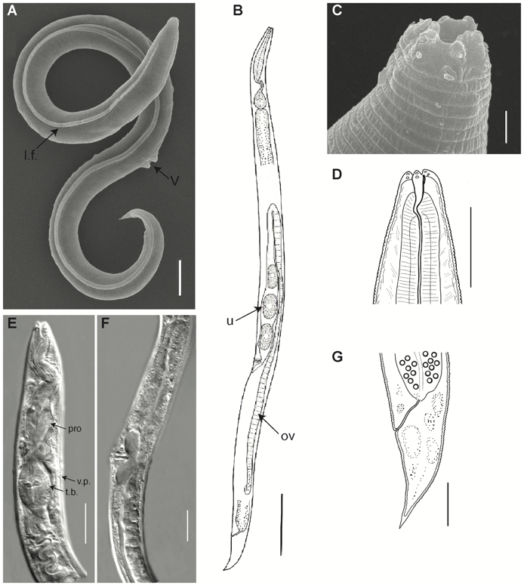

During the period August 20-26, 2023, the All-Russian scientific and practical conference “PERMAFROST-AFFECTED SOILS IN THE ANTHROPOCENE” was held in the city of Salekhard (Yamalo-Nenets Autonomous Region, Russia). The 4-day scientific program included a plenary session and 9 thematic scientific sections (in total, 4 plenary reports were heard; 69 oral reports; 55 poster reports). Additionally, 4 round tables (22 reports), 1 youth science quiz and 1 science master class from the SoilArt group (M.V. Lomonosov Moscow State University) were held. The conference was concluded with a 2-day field soil-permafrost excursion, during which about 100 participants visited the “Rai-Iz” mountain range, the “Seven Larches” carbon monitoring site, examined projects for landscaping urban spaces in the Arctic (using the example of the city of Salekhard), as well as visited the unique “Vavilov Field” of the Yamal Experimental Agricultural Station.

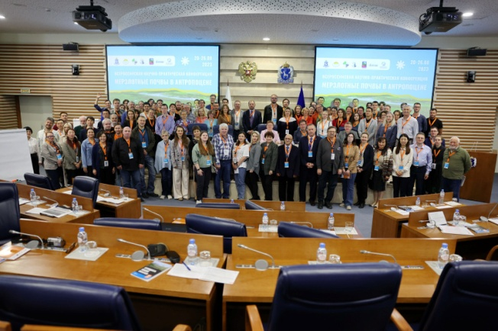

*****

**Cryolithology and Glaciology Department, Geographical Faculty, Lomonosov Moscow State University**

**In 2023** researchers of Cryolithology and Glaciology Department, Geographical Faculty, Lomonosov Moscow State University continues their study in the framework of 5-year project “The cryosphere evolution under climate change and anthropogenic impact”.

As a result of ongoing research, the geochemical features of the tabular ground ice, ice wedges and lens ice from the eastern coast of the Faddeevsky Peninsula (East Siberian Arctic) have been established. Dissolved organic matter composition, supposed to record the paleoenvironment of the freezing process, was for the first time tried as a biomarker for paleoenvironmental reconstructions of ground ice formation.

It was carried out an analysis of the anthropogenic influence on the permafrost warming and the activation of cryogenic processes. The degree of deformation of buildings and infrastructure facilities varies over a very wide range: in industrial centers from 20 to 80%, in small indigenous settlements up to 100%.

It was continued study of glacial hazards as well as mass balance monitoring of the Dzhankuat and Kolka glaciers (Central Caucasus), glaciers of the Aktru basin (Altai), glaciers of the Inner Tien Shan (Karabatkak, Sary-Tor, Bordu), and the Polar Urals. On the Dzhankuat glacier, the 2022/23 balance year continued a series of negative values, uninterrupted since 2004/05. However, the upward trend in snow accumulation continues and a distinctive feature of the past accumulation season is a significant share of avalanche input, which was estimated at 6%. It was revealed that, unlike the Caucasus, in 2022/23 in the Tien Shan, natural conditions this season were much less favorable for glaciation. Values of mass balance of the glaciers were included in the annual national report for the World Glacier Monitoring Service.

New modeled characteristics of snow avalanches in the studied areas of the Caucasus, Kamchatka, and Khibiny mountains were obtained. In the Khibiny Mountains over the past ten years, quantitative indicators of social avalanche risk have increased 7 times due to the rising number of tourists.

Some of the scientific results obtained were presented at the 6th European Conference on Permafrost, AGU Fall Meeting.